Main Exam : 1st October to 14th October 2026
• Reporting Time: 7:55 a.m.
• Dispersal Time: 12:00 p.m.
-----------------------------------------------
1st October: Social Studies
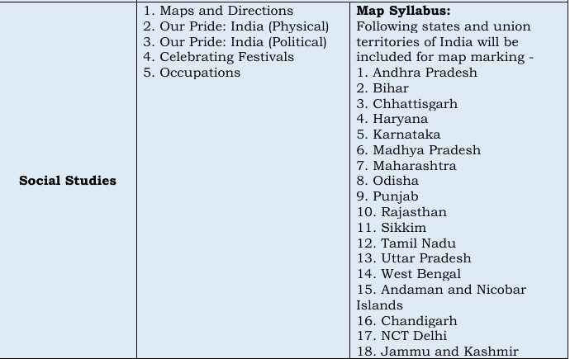

5th October : Hindi Advanced
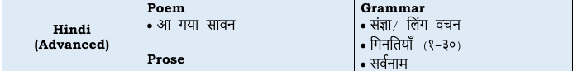
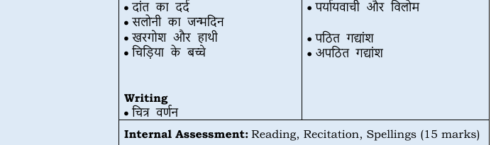

7th October : Mathematics
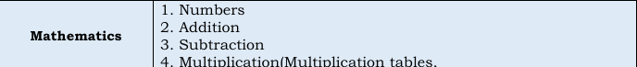
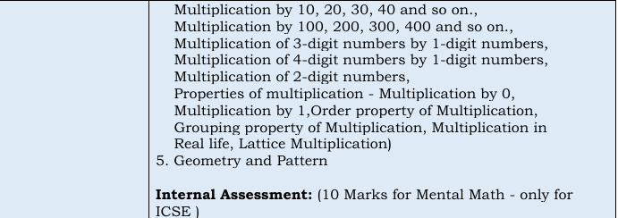

9th October : Language Arts
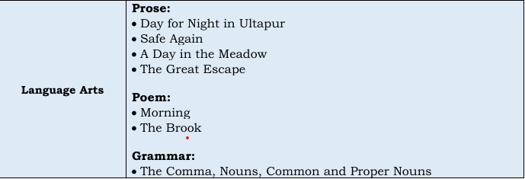
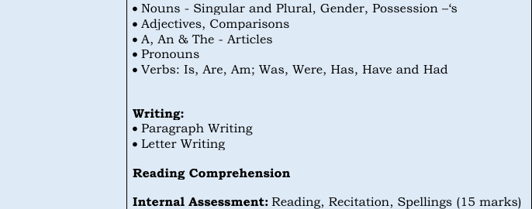

12th October : General Science
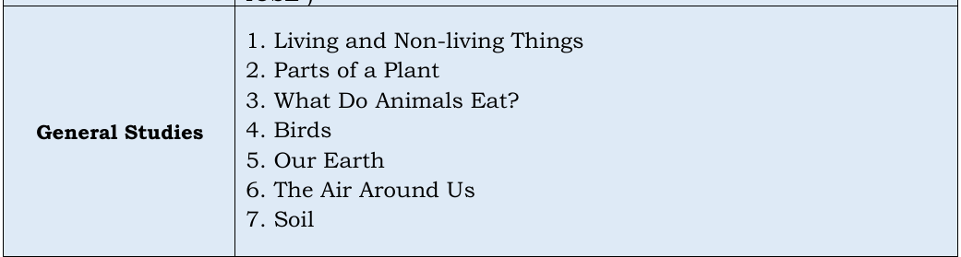

14th October Kannada Basic
